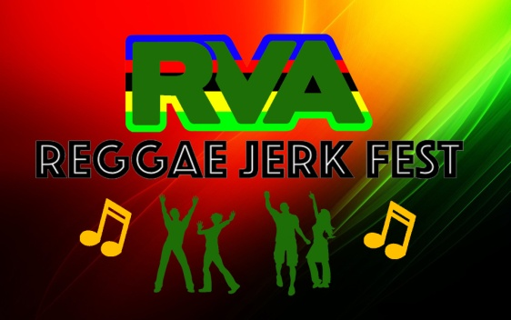

Presented By: OneByOne Initiative (501c3)

RVA REGGEA JERK FEST - 2022 - VENDOR APPLICATION
VENUE: BROWN'S ISLAND, RICHMOND, VA 23219
Saturday, July 9, 12.00 pm – 9:30 pm
Vendor Application Deadline: June 10, 2022

BUSINESS ENTITY: ______________________________________________________________________________

Address: ______________________________________________________________________________

City: ________________________________________________ State: ________ Zip: ________

Contact Name: ________________________________________ Phone: __________________
Email: ________________________________________________________________

VENDOR CATEGORY:
☐ Crafts/Merchandize ☐ Food Vendor ☐ Community Group/Organization
☐ Other ______________________________________________________________

Cost of Vending Space:
Food Vendor $550.00
Crafts/Merchandize/Exhibition $250.00
Non-profit/Information $50.00
FULL PAYMENT IS DUE ONCE VENDOR HAS BEEN NOTIFIED AND PARTICIPATION CONFIRMED
All Payments should be in the form of a cashier’s check or money order payable to OneByOne Initiative.
Event Reminders:
- The space will be available at 7:00 a.m. for set-up. Vendors will have one hour after the event to break down and remove exhibit from the park. No exhibits may be taken down prior to 9:30 pm.

- Vendors must abide by the Load-in schedule set with the promoter/coordinator to ensure efficient set up for the festival.

- You will be provided with a 10’ x 10’ space, unless otherwise approved by event coordinators. If additional space is used by the vendor additional charges may be applied. Exhibitor must provide their own tables, chairs and tent.

- Electricity is provided at the facility. If you have special electricity needs, we suggest you have your own generator and extension cords. Please clear all special electrical needs with the promoter at least 2 week prior to the event.

- Water is provided at the venue. It may require transportation to the vendor location.

- Vendor must keep exhibit open and staffed continuously from 12:00 pm - 9:30 p.m.

- The event is rain or shine.

Business License and Insurance Requirements: (Mandatory)
All food vendors are required to have a City of Richmond Business License and General Liability Insurance with limits of not less than $1 million and $2 million aggregate.

The Certificate of Insurance must include the following phrase: "The City of Richmond, Venture Richmond, and their agents, volunteers and employees are name as additional insured as respects in the event to be held on July 9th 2022 at Browns' Island in Richmond, VA." Venture Richmond must be listed as a Certificate Holder.

All merchandise vendors are required to have a City of Richmond Business License.

Submit all the required documents. Applications will not be confirmed until all required documents are received.

Vendor Signature: ________________________________________ Date: ________

